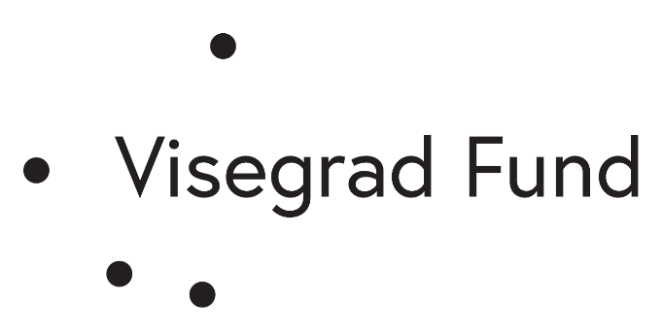

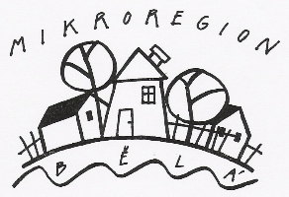

"Same problems, different solutions"
Nr. 22120008

Brochure
"We help solve problems"

December 2022

Content
• introduction (project description, project goal)
• associations and municipalities – initial situation
• exemplary implemented projects in individual countries
• problems to be solved and proposed solutions
• strengths and weaknesses of the project
• continuation of the project and recommendations
• photodocumentation
• conclusion

Introduction

The foundation document of the Visegrad Fund states: “We are looking for organizations that aim to share knowledge, improve innovation and engage citizens in the Visegrad region and across Central and Eastern Europe. We want to partner with those who can make a difference – whether you're a small grassroots group focused on the local community or an experienced national organisation.”
The purpose of the project, which was implemented, is to emphasize the role of associations in the development of municipalities, their financing by the municipalities and the search for their areas of activity in the municipalities. By holding both local meetings and partner meetings in V4, space was created for monitoring the stated requirements and, in particular, the opportunity to share exemplary experiences of well-implemented association projects from the territory of individual project partners and their possible implementation in the territory of other partners.
On the basis of this and other information and the experience of cooperating partners, we decided to come up with a project that would fulfill the requirements of the Fund and be the next step in the development of the partners with whom we agreed to submit a project application. The main partner and at the same time the applicant for the project subsidy is Microregion Bělá (CZ), and other partners are Gmina Kłodzko (PL), Microregion Klátovské rameno (SK) and the municipality of Tényö (HU).
We want to take several steps towards the mentioned goal. Monitoring of the situation in the regions of individual partners and selection of exemplary approaches for mutual cooperation between associations and municipalities has already been carried out. At the next two working meetings in the Czech Republic and Slovakia, with one-day visits to Poland and Hungary, we want to discuss the positives of the cooperation of individual types of associations and municipalities with the possibility of adapting these outputs to local conditions and implementing them in the countries of other partners. Already the first step of the project - the monitoring meeting - showed that associations and municipalities are interested in sharing their experiences and that the project makes sense.
We want to inform associations and municipalities from the territory of all partners about the results of these meetings in the form of an electronic brochure.

Associations and municipalities, initial situation

At the individual monitoring meetings, the purpose of which was to obtain initial information about the situation in the cooperation of associations and municipalities, information was heard on the one hand about the current situation and status, and to a lesser extent also requests for mutual assistance, on which both municipalities and associations have slightly different opinions. In general, however, it can be stated that associations have variously long histories in municipalities, and it is necessary to realize that these are interest associations. It emerged from individual meetings and other experiences that there is not much awareness of mutual need for help, and this particular project should open up the topic of mutual need more for discussion and implementation of mutual cooperation. Both groups realized that by improving awareness of possibilities and needs, there will be a higher intensity of regional development.

Sample implemented projects in individual countries (summary)

Societies
- Help in organizing events in municipalities
- Production of small gift items
- Maintenance of entrusted property (repairs of clubhouses, painting, maintenance of surroundings)
- Help with the maintenance of public spaces
- Provision of refreshments at social anniversaries and community events
- Promotion of the municipality during association events
- Providing facilities for events of regional importance
- Commenting on municipal documents
- Provision of leisure activities
- Organizing events for youth and other interest and age groups
- Help with the maintenance of public spaces
- Maintenance of water courses, wells and non-agricultural areas

Municipality
- Transmission of information through representatives of associations who are members of councils
- Financial contributions to the operating costs of associations
- Material needed for the maintenance of entrusted property
- Support of important association events
- Inclusion of some demands of associations in the municipal budget
- Ensuring meetings of representatives of associations and members of local governments
- Providing the opportunity to present associations in municipal newsletters
- Presenting ideas and needs for improving the environment in municipalities
- Offer to use municipal equipment (with municipal employees)

Problems and offers to solve them

Regarding the above-mentioned needs and offers, in most cases the list is two-sided, i.e. some associations and some municipalities have individual points expressed as an offer with a solution and some as a need to be solved. As we subsequently found out, some interesting topics were a good basis for further discussion at the next two meetings.
It is gratifying that both municipalities and associations are interested in cooperation and problem solving. They realize that it is good to solve the shortcomings in the municipalities together, and they also see shifts in the development of the region behind this.
During individual meetings in the territory of all partners, we realized that the problem in the environment of one partner is not so big due to other contexts, and vice versa, a small deficiency can lead to other problems. This point of view was ultimately the purpose of the project.
The following table shows topics for sharing both resolved issues and deficiencies that need to be addressed. This is a simplified, partially generalized form.

Cooperation between municipalities and associations - topics for sharing

Activity - topic | Association | Earth
Watercourse cleaning, bush cutting | Firefighters | CZ, SK, PL
Maintenance of armories and grounds, maintenance of equipment | Firefighters | PL, SK
Helping mothers with young children | Maternity center | CZ
Maintenance of sports buildings, mowing in areas, sports competitions | Athletes | SK, HU
Furniture coatings, waste collection in the field | Scouts | CZ
Spaces for leisure activities - sorting, maintenance | Athletes | SK, CZ
Watercourse cleaning, wells, greenery in nature, fishing races | Fishermen | CZ
Planting of plants and trees, modification of areas for roaming | Beekeepers | PL, CZ
Removal of encroached trees, planting trees, removal of brushwood, work in the forest | Hunters | CZ
Cutting and drying grass in inaccessible locations | Hunters | CZ
Maintenance of educational trails and rest areas | Fishermen | CZ
Maintenance of cemeteries | Development associations | PL, HU
Important people in cemeteries - lists | Cultural associations | CZ, SK, PL, HU
Podklady pro vydávání místních časopisů, výstavy | Cultural associations | CZ,
Organizational assistance, production of gift items | Seniors | PL, CZ
Lectures - transfer of experience | Seniors | PL
Neighborly help, shopping, provision of services | Seniors | CZ, SK
Gift items, exhibitions, skills classes, bazaar | Maternity centers | CZ
Landscaping, planting and pruning of trees and shrubs, lectures | Development associations | CZ, PL, SK
Skills courses, organizational assistance, medicinal plants | Women - housewives | PL, SK
Meetings with citizens, questionnaires | Development associations | CZ, PL
Sorting waste, ensuring order in containers | Development associations | HU, PL, SK, CZ

The assistance of municipalities to associations mainly consists in renting premises for the activities of associations and expedient financing of their activities. Municipalities' approaches to financing associations are different, either a one-time amount from the municipal budget, or sometimes at the same time a contribution to individual events organized for the benefit of municipalities.

Strengths and weaknesses of the project

Strengths of the project partnership
- Awareness of the activities of associations and their potential
- Familiarization with the financial possibilities of municipalities outside one's own region
- Sample diversity of needs in different regions
- Obtaining ideas for the activities of associations and municipalities
- Associations' interest in information from the sphere of interest activities abroad
- New information, approaches and experiences to solve problems
- Better information of municipalities about associations in the region and with partners
- Passing on experiences – even negative ones
- Establishing personal friendships
- Resolution of oral communication without the paid services of an interpreter

Weaknesses of project partnership
- Geographical distance for the set
- Financial costs of joint events due to greater distance
- Relative language barrier with the Hungarian partner
- Little time for a more detailed knowledge of life in the environment of partners
- Problems with increasing the cost of services in the project during its course

Project continuation and recommendations

We have new experience in using the approaches of organizations with similar interests, which sometimes have proven approaches to solving the problem and sometimes do not see the given situation as problematic. The project showed that other than traditional solutions to problems can be beneficial outside the given region, even in other partner countries.
We will try to initiate the processing of lists of assistance needs in the municipalities, and they will then be made available to the associations with an offer of their solutions. We believe that funding from municipalities must also enter into this process. Assistance from municipalities to associations is also given by an individual, perhaps proven, system in different regions. Here, too, we want to prepare ideas and options for municipalities that may sometimes seem unfeasible, but in some cases work for mutual benefit.
As the applicant and partners, we want to use the topics that were presented in the project to further spread the experience in the wider area. We are considering organizing local seminars in partner countries, which was also in the original intention stated in the project application.
For this project to be meaningful, it cannot end with the handing over of the final report. We managed to monitor the problems in the regions and at the same time their exemplary solutions. It turned out that working relations between local governments and associations can gain quality just by correctly specifying the problem to be solved and by discussing and coordinated involvement in its solution.
As mentioned in another part, only a small part of associations in the regions participated in the project, but we want to offer their experience to other organizations in the regions. We definitely want to follow up on the first activity of the project – the Monitoring Meeting, although to the extent that the individual partners choose. But the point must be greater communication, and this will certainly lead to cooperation. We mainly see the role of the applicant and project partners in this.

FOTO

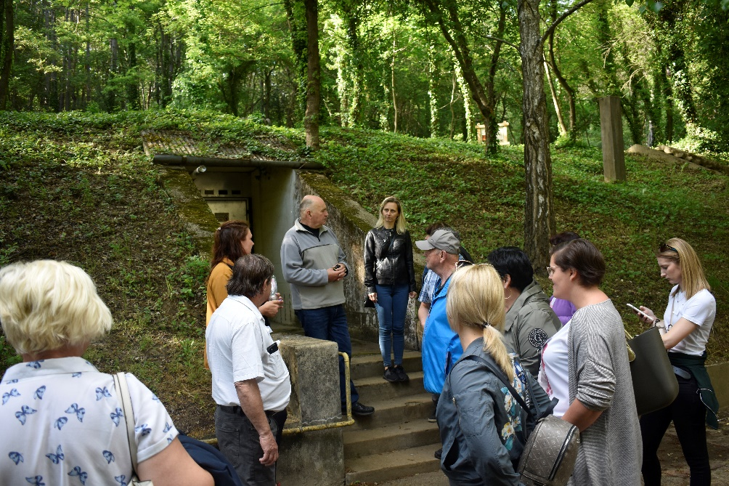

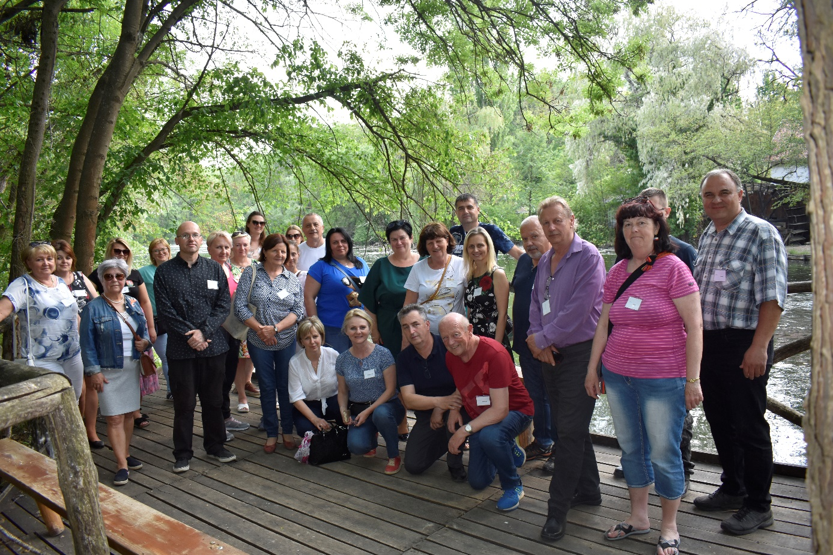

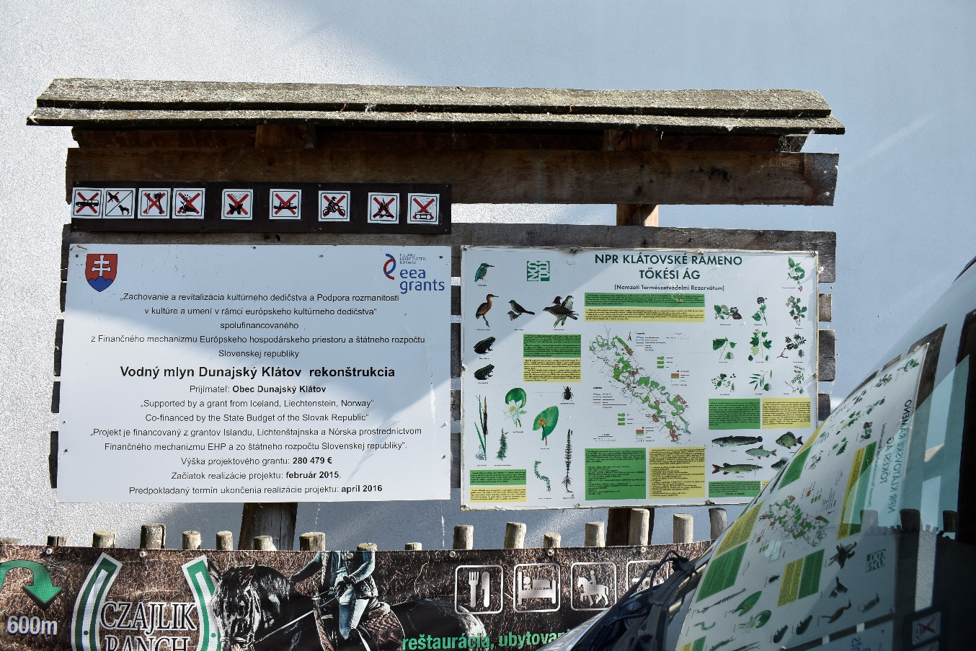

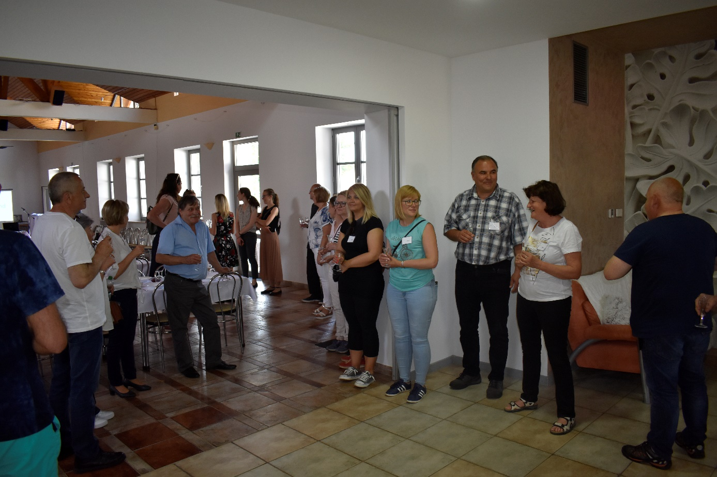

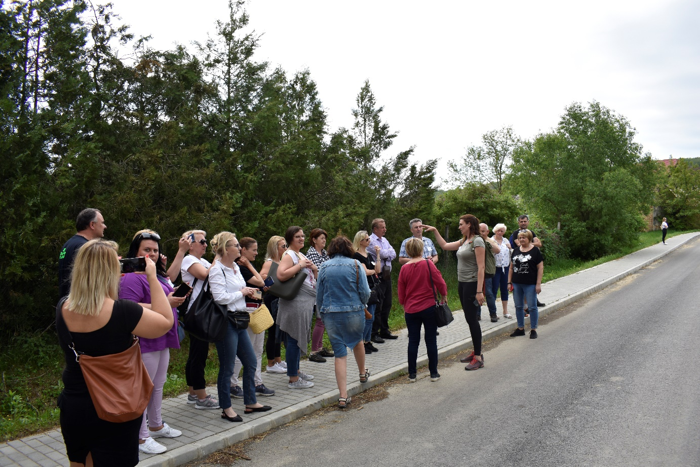

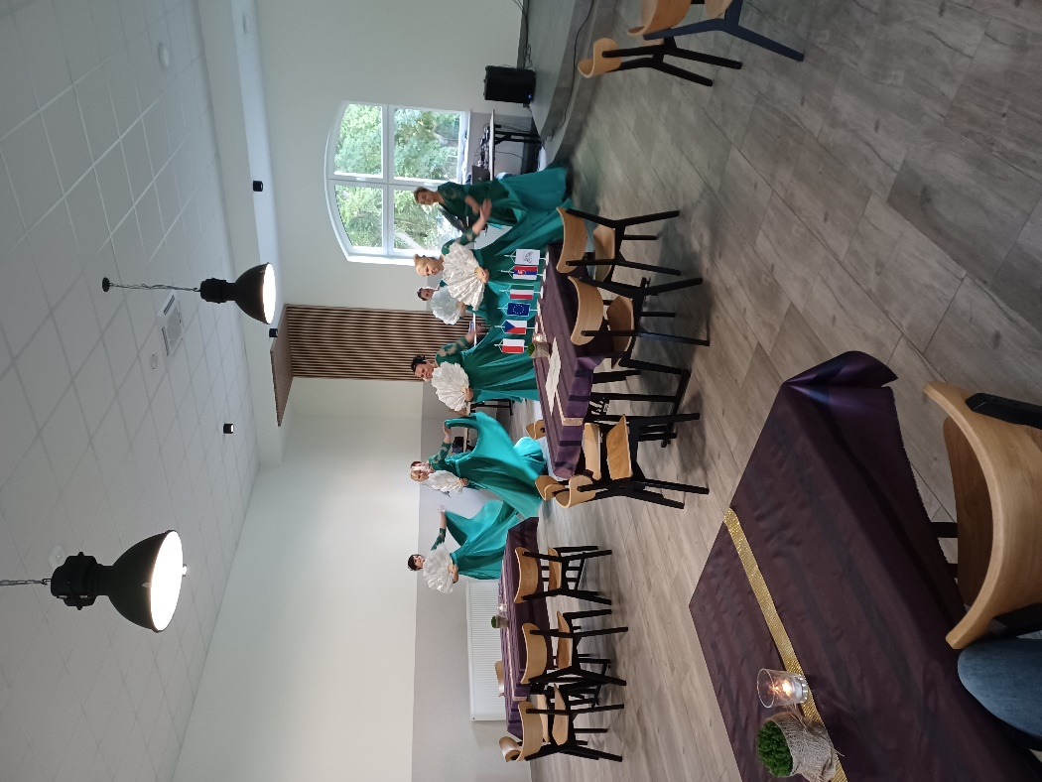

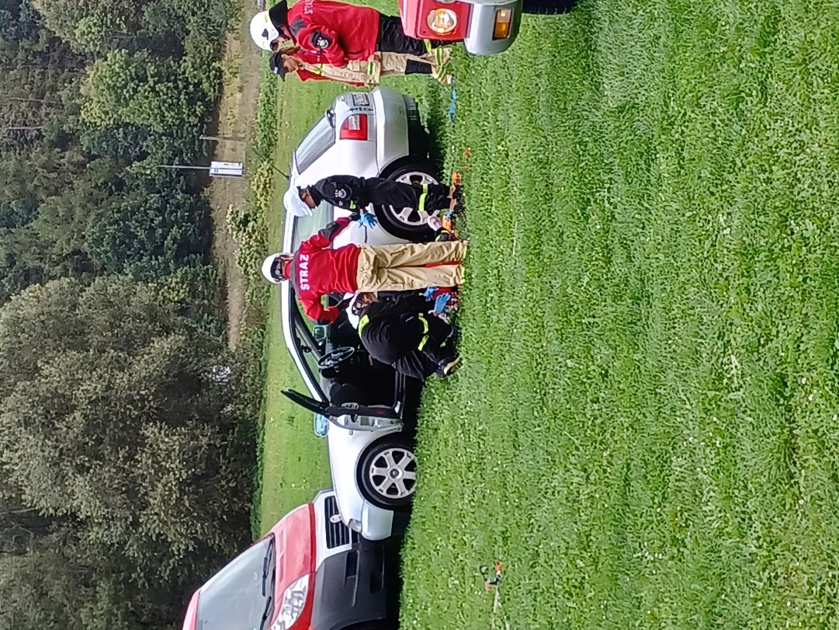

Conclusion

The project "Same problems, different solutions" helped the participating partners open the issue of cooperation between associations and municipalities. We believe that there has been a change in the view of the need for mutual cooperation to solve problems and shortcomings in the regions and, thanks to the wider international context, also to compare these facts in a different environment.

